|  |  |
| --- | --- |
| **BiTP – DF Korean Center Application Form** | |
|  | |
|  | |

|  |  |  |  |  |  |  |
| --- | --- | --- | --- | --- | --- | --- |
| PHOTO  (35㎜×45㎜)  *Color picture within last 6 month | Name | Full name | | | First name | |
| *Kim Daewoong* | | | *Daewoong* | |
| Date of Birth | *1998-01-01* | Gender | [ ] M  [ ] F | Nationality | *Indonesia* |
| Address |  | | | | |
| Phone Number | *0818-1111-xxxx* | | Email |  | |
| Occupation | *Manager* | | Affiliation | *Daewoong Foundation* | |

Education History

|  |  |  |  |  |  |  |  |
| --- | --- | --- | --- | --- | --- | --- | --- |
| Category | School Name | Location | Major | Semester | Degree | School period (yyyy.mm) | (GPA) |
| University | *Daewoong University* | *Korea* | *management* | *graduated* | *Bachelor* | *September 2017 ~ September 2021* | *4.0/4.5* |
| other |  |  |  |  |  |  |  |

Korean Language Proficiency

|  |  |  |  |  |  |
| --- | --- | --- | --- | --- | --- |
| Category | Level | Score | Organization | Printed Date | Valid Until |
| *TOPIK* | *6* | *240* | *NIIED* | *2022-01-30* | *2024-01-22* |
|  |  |  |  |  |  |

Activity and Achievement Record

|  |  |  |  |  |
| --- | --- | --- | --- | --- |
| Program | Detail of Activity | Achievement | Organization | Date of Achievement |
|  |  |  |  |  |
|  |  |  |  |  |
|  |  |  |  |  |

[Essay]

※ Instructions:

- Type in English.

- Please provide an answer of 70 ~ 250 words for each question.

1. How did you become interested in Korea, and what is the reason you want to learn the Korean language?

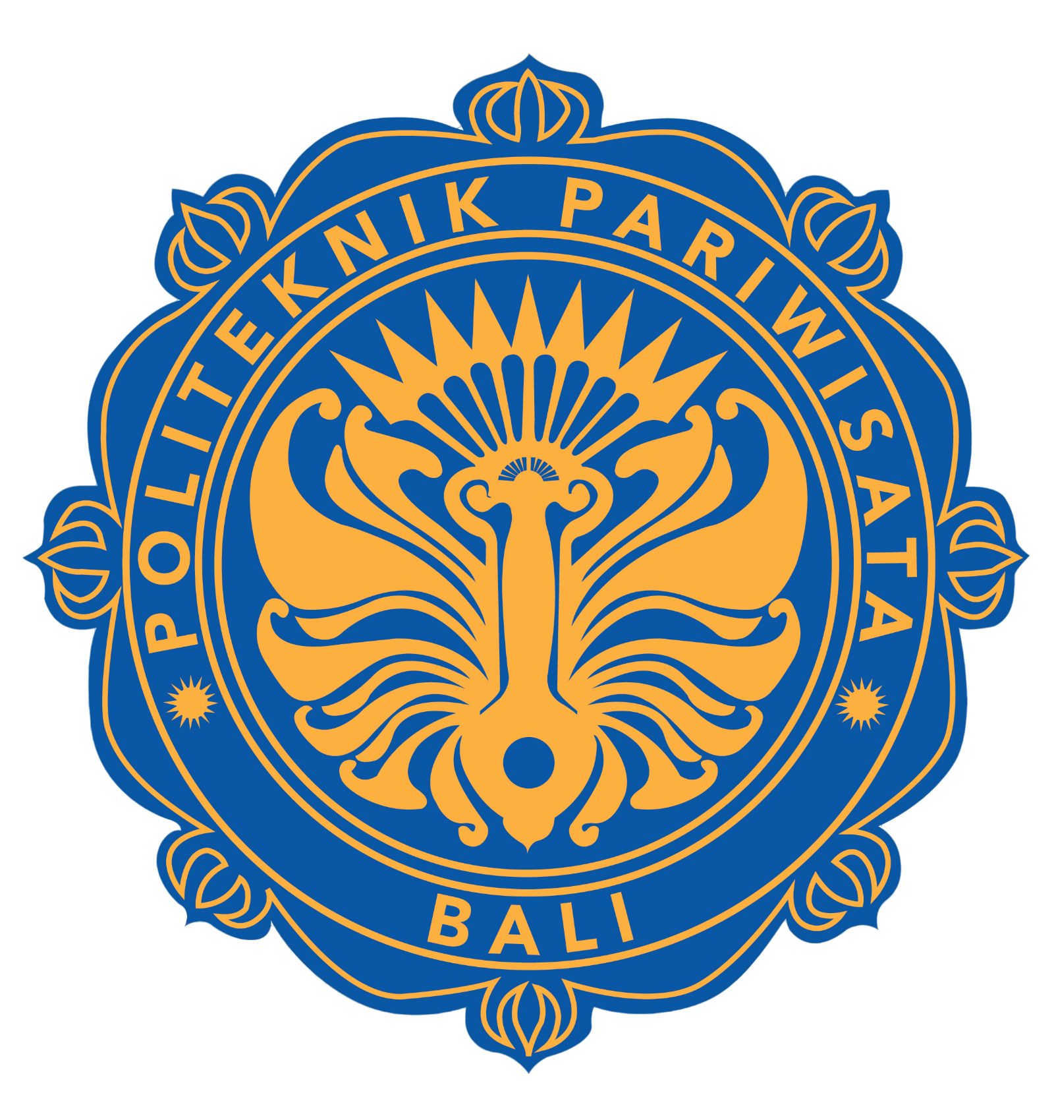

1. What are your plans for the future, and how have you worked towards achieving them?



1. How do you plan to utilize your Korean language skills in your future plans?